Pope Francis approves miracle needed to canonize Fatima visionaries

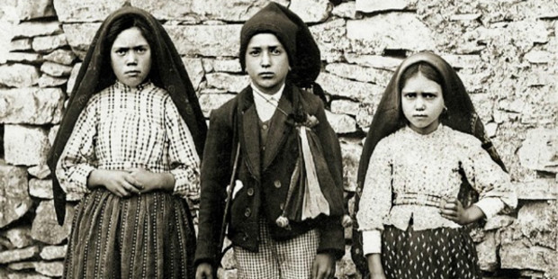

Francisco and Jacinta Marto will be among the youngest saints

canonized in the history of the Church.

Pope Francis has issued a decree paving the way for the canonization of two of the Fatima visionaries, brother and sister Francesco and Jacinta Marto. While an official date has not yet been released by the Vatican, Italian media reports suggest the pope may canonize the two shepherd children during his May 12-13 visit to Fatima, to mark the 100th anniversary of the Marian apparitions. The announcement came this morning, after the pope met with Cardinal Angelo Amato, Prefect of the Congregation for the Causes of the Saints, and authorized the congregation to promulgate a decree regarding the miracle attributed to the intercession of the two children of Fatima. It is the second and final miracle needed for their canonization. Francisco and Jacinta will be numbered among the youngest saints in the history of the Catholic Church.

The miracle
As today’s decree attests, a single miracle has been attributed to the intercession of Franciso and Jacinta. This was also the case in 2000, when Pope John Paul II beatified the brother and sister: although initially two distinct causes had been opened, only one miracle — attributed to their joint intercession — was required for their beatification. The canonical process to examine the miracle approved today was opened on October 13, 2004. The case involved the healing of an infant named Felipe Moura Marques who, when the process was opened, was 5 years old. Born to a Portuguese couple living in Switzerland, Felipe was born with type 1 diabetes, a disease considered incurable. His mother and his grandmother, who had a great devotion to Francisco and Jacinta, took the child to the Marian Shrine in Fatima and placed him near the tombs of the two blessed. On May 13, 2000, while watching Pope John Paul II beatify the two shepherd children on television, Felipe’s mother prayed to Francisco and Jacinta for the health of their son. Since that time, Felipe has not needed to take insulin and has been completely cured of diabetes.

Fatima
On May 13, 1917, the Virgin Mary appeared to Lucia Santos (10) and her cousins Francisco (9) and Jacinta Marto (7), in the valley of Cova da Iria, in Fatima, Portugal. Our Lady addressed the pain of a world torn by war and revolutions, and called for prayer, penance, and redemptive suffering to prevent war and to save souls from eternal damnation. Mary told the children to pray the Rosary often, saying: “Through the Rosary, you can stop wars.”
The Blessed Virgin appeared on the 13th day of each month, for the next six months. Then, on Sunday, October 13, 1917, the “Miracle of the Sun” was seen by an estimated 30,000 to 100,000 people. Within two years, young Francisco died at the age of 11, while Jacinta died one year later, at the age of 10. Both were victims of the Spanish flu pandemic which spread across the world after World War I. Although young, Francisco and Jacinta devoted the end of their lives to intense prayer and offered their sufferings, in union with Christ, in reparation for sin and for the salvation of souls.

Sr. Lucia
Earlier this year, on February 13, 2017, the third of the Fatima visionaries — Sr. Lúcia Santos — also took a further step in the canonization process. The only surviving visionary in the years following the apparitions, Sr. Lucia entered a convent when she was of age and later transferred to a Discalced Carmelite convent in Coimbra, Portugal.
In 1941, Sr. Lucia revealed that Our Lady had entrusted the children with three “secrets.” The first secret was a vision of Hell. The second concerned the end of the First World War and a warning of World War II. When asked by her bishop to reveal the third secret, Sr. Lucia was not convinced that God had clearly authorized her to act in this manner. Later however, at the order of her bishop, she wrote down the third secret and placed it in a sealed envelope not to be opened until 1960. This envelope was later delivered to the Vatican and was eventually published by the Holy See in June, 2000.
Sr. Lucia attended Francisco and Jacinta’s beatifications in 2000, and died in 2005 at the age of 98. Three years later, Pope Benedict XVI waived the usual 5-year waiting period to begin the process of her beatification. The diocesan phase of the process of canonization concluded last month. Every pope since Pius XII has expressed his belief in the divine and supernatural character of the events which took place at Fatima. John Paul II attributed his survival after an assassination attempt on May 13, 1981 to the intercession of Our Lady of Fatima.

Pope Francis
Pope Francis will journey to Fatima on May 12-13, 2017 to mark the centenary of the Marian apparitions. Francis will be the fourth pope to visit the shrine, following Blessed Paul VI, St. John Paul II and Pope Benedict XVI.
Last year, on May 11, 2016, he spoke about Our Lady of Fatima during the weekly general audience, saying: “She asks us to never offend God again. She forewarns all humanity about the necessity of abandoning oneself to God, the source of love and mercy. Following the example of St. John Paul II, a great devotee of Our Lady of Fatima, let us listen attentively to the Mother of God and ask for peace for the world.”

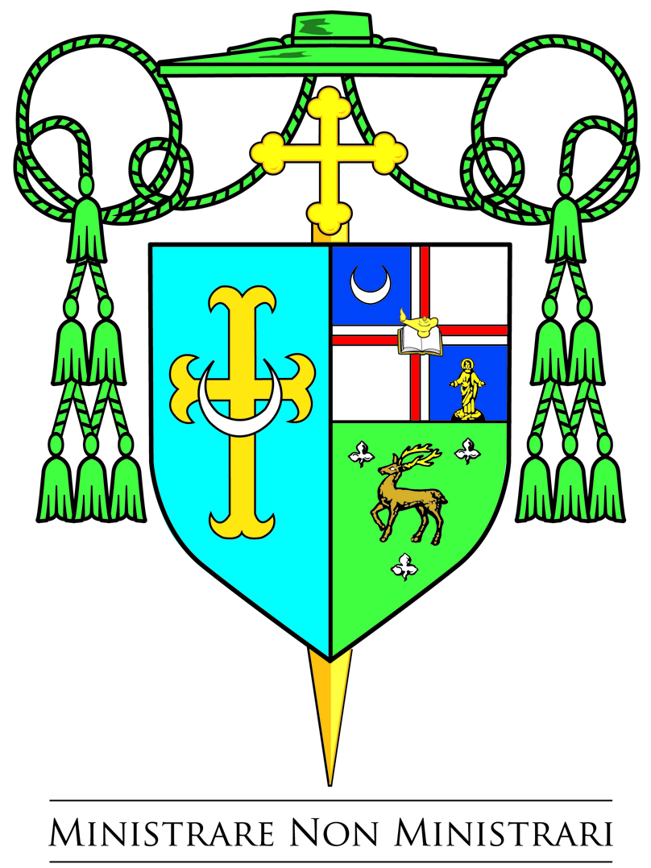

DIOCESE OF TRENTON
701 LAWRENCEVILLE ROAD
POST OFFICE BOX 5147
TRENTON, NEW JERSEY 08638-0147
Office of the Bishop
May 5, 2017

Pope Francis Grants Plenary Indulgence* - For Our Lady of Fatima Centennial
Jubilee Year of Fatima ~ Granting of Plenary Indulgence
Pope Francis has granted a plenary indulgence* opportunity for the 100th anniversary of the Fatima apparitions throughout the centennial year, from the 27th of November 2016 till the 26th of November 2017.
There are three ways to obtain the plenary indulgence, detailed in a statement from the Fatima Shrine in Portugal.
To obtain the plenary indulgence, the faithful who follow one of these three ways must also fulfill the ordinary conditions: (1) go to Confession and Communion,(2) be interiorly detached from sin, and (3) pray for the intentions of the Holy Father, usually the Creed, the Our Father, the Hail Mary and the Glory Be. The three ways are:
- Make a pilgrimage to the Fatima Shrine In Portugal:
To the faithful who make a pilgrimage to the Fatima Shrine in Portugal and participate in a celebration of prayer dedicated to the Virgin. In addition, the faithful must pray the Our Father, recite the Creed and invoke the Mother of God. OR,
- Pray before any statue of Our Lady of Fatima
To the faithful who visit with devotion a statue of Our Lady of Fatima solemnly exposed for public veneration in any church, oratory or proper place during the days of the anniversary of the apparitions, the 13th of each month from May to October 2017, and there devoutly participate in some celebration or prayer in honor of the Virgin Mary. In addition, the faithful must pray the Our Father, recite the Creed and invoke Our Lady of Fatima.
- The elderly and infirm
To the faithful who, because of age, illness or other serious cause, are unable to get around, may pray in front of a statue of Our Lady of Fatima and must spiritually unite themselves to the jubilee celebrations on the days of the apparitions, the 13th of each month, between May and October 2017. They must also “offer to merciful God with confidence, through Mary, their prayers and sufferings or the sacrifices they make in their own lives.”
*"An indulgence is a remission before God of the temporal punishment due to sins whose guilt has already been forgiven, which the faithful Christian who is duly disposed gains under certain prescribed conditions through the action of the Church which, as the minister of redemption, dispenses and applies with authority the treasury of the satisfactions of Christ and the saints (canon 992 and Catechism of the Catholic Church, 1471).” A plenary indulgence is a complete remission of temporal punishment due to sins and is limited to one per day.
Our Lady of Fatima, pray for us!
Respectfully yours in the Lord,
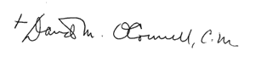
Most Reverend David M. O’Connell, C.M., J.C.D.
Bishop of Trenton

