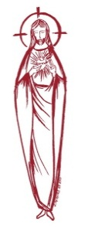**SACRED HEART PARISH**

Sacred Heart Parish Founded 1814, The First Catholic Parish in the STate of New Jersey

Sacred Heart Church, 343 South broad Street, Trenton, New Jersey 08608

Holy Cross Church, 233 Adeline Street, Trenton, New Jersey 08611

**ALL ARE WELCOME**

Whatever your present status in the Catholic Church, whatever your current family or marital situation,

Whatever your past or present religious affiliation, whatever your personal history, age, background, or

race, whatever your own self-image or esteem, you are invited, welcomed, accepted, loved and

respected at the Parish of the Sacred Heart.

**PASTOR**

Rev. Msgr. Dennis A. Apoldite

[frdennis@trentonsacredheart.org](mailto:frdennis@trentonsacredheart.org)

**PAROCHIAL VICAR**

Rev. Charles Muorah

**Felician Residence for Clergy**

233 Adeline Street, Trenton, New Jersey 08611

609-393-4826 ext. 108 for Fr Charles

**DEACON**

Dr. Christian Nnajiofor

**Business Manager / ADMINISTRATIVE ASSISTANT**

John DeSantis: secretary@trentonsacredheart.org

**Administrator of religious education**

Mary Tovar: reled@trentonsacredheart.org

**COORDINATORS OF SACRED MUSIC**

Natalie Megules ~ 609-575-6484

Rupert Peters ~ Gospel Mass 609-442-7871

**MAINTENANCE DEPARTMENT**

Frank Rios

**Trustees**

Jack Breuer and Ellieen Ancrum Ingbritsen,

**OFFICE HOURS**

9:00am – 4:00pm Monday – Friday

**SACRED HEART PARISH OFFICE**

343 South Broad Street, Trenton, NJ 08608

**Phone: (609) 393-2801 ~ Fax: (609) 989-8997**

**WEB PAGE:**

www.trentonsacredheart.org

**CEMETERY RECORDS**

Contact The Office of Catholic Cemeteries at 609-394-2017 or DirectorofCemeteries@DioceseofTrenton.org

**SACRAMENTAL RECORDS**

Sacred Heart Church, Saint John’s Church, Saint Francis Church, Saints Peter and Paul Church, Saint Stanislaus Church, Holy Cross Church, Blessed Sacrament Church, Our Lady of Divine Shepherd Church, Blessed Sacrament/Our Lady of Divine Shepherd Parish and Divine Mercy Parish.

**Liturgy Schedule**

**Sacred Heart**

Monday, Tuesday, Wednesday and Friday

12:10 Noon

Saturday Evening 5:15 PM

Sunday Morning 9:00 and 11:15 AM

**HOLY CROSS**

Monday, Thursday and Friday 8:00 AM

Saturday Evening 4:00 PM

Sunday Morning 10:00 AM Gospel

12:00 Noon Polish

For each Holy Day please reference the bulletin

**SACRAMENTS**

**BAPTISM**

Please call the Parish Office at least one month in advance.

**RECONCILIATION**

Every First Friday following the 12:10PM Mass SHC

Saturday afternoon ~ 4:30 to 5:00 PM SHC

Every Saturday from 3:30 to 3:50 PM HCC

Every Sunday 9:30 to 9:50AM HCC

and by appointment.

**EUCHARISTIC ADORATION**

First Saturday of the Month 2:30 to 3:30 pm

in Holy Cross Church

**MARRIAGE**

Please call the Parish Priest at least one year in advance to set up initial meeting and to confirm a wedding

date and time.

**ANOINTING OF THE SICK**

Please call the Priests any time 609-393-2801.

**COMMUNION TO THE HOMEBOUND**

Call the Parish Office to schedule home visit.

**CONSIDERING PRIESTHOOD?**

Email: [Vocations@DioceseofTrenton.org](mailto:Vocations@DioceseofTrenton.org)



**The Most Holy Trinity**

**June 4, 2023**

**MASS INTENTIONS**

**Saturday, June 3**

4:00 pm ~ Deceased Members of the Biesiada Family

5:15 pm SHC ~ Lou Umscheid

**Sunday, June 4 Most Holy Trinity**

9:00 SHC ~ Altar Rosary Society & Fr Mick Lambeth

10:00 ~ The Intentions of the People of the Parish

11:15 SHC ~ Dolores Mannain

12:00 HCC Polish ~ Zbigniew Kolodziej

**Monday, June 5**

8:00 am HCC ~ Ruthmarie Manger

12:10pm SHC ~ Eileen Kostrzewa

**Tuesday, June 6**

12:10 pm SHC ~ Benigna Donato

**Wednesday, June 7**

12:10 pm SHC ~Pat Tagliaferri

**Thursday, June 8**

8:00 am HCC ~ People of Sacred Heart Parish

**Friday, June 9**

8:00 am HCC ~ John Kostrzewa

12:10pm SHC ~ Deacon John Grussler

**Saturday, June 10**

4:00 pm ~ Shelby Rowe and Dolores Krysztofik

5:15 pm SHC ~ Ken and Lucille Fisher

**Sunday, June 11 ~ Corpus Christi**

9:00 SHC ~ Holy Name & Hoch and Ridorfino Families

10:00 ~ The Intentions of the People of the Parish

11:15 SHC ~ Marie Audine Boyer

12:00 HCC Polish ~ Bozena, Antono & Wincenty Plotka

**OUR SICK LIST**

Carole Minotti, Dolores DeBlasio, Ruby Covington, Judith Santigo, Ching Kukis, Dan Breese Jr, Brenna Kennedy-Moore, Dawn Chia, Mark Friedman, Robert Leighton, Patrick Leighton, Alexander A. Ladnyk, Kelly Nitti, Lauren Clayton, Joseph Edralin, Margie Tiongson, Kevin, Vincent Cooper, Jr., Gail Ladnyk, Leo Genovesi, Sloane Donnelly, Richard Buckley, Tony Ragolia, Barbara Burrows, John Matthews, Robert Mahon, Charles Burrows, Dorothy Amoroso, Maryann Sullivan, Regina Friedman, Rita Mich, Stanley Winowicz, Greg Schafer, Jack Hardiman, Paul Leighton, Amy Birk, Julia Grazioli, Matt and Leona Tydryszewski.

**OUR DECEASED**

Judy Flaherty, Mary Habres, Marie Theresa Desiderio, and our friends at South Village, Riverside Nursing and Rehabilitation Center, Mill House and Waters Edge.

**MINISTRY SCHEDULE**

**Saturday, June 3**

4:00pm HCC ~ Fr Charles L. V Zielinski Em. L Bliznawiczus

5:15pm Msgr. Dennis L. L Seabrook EM. R Hoyer & J Kazior

**Sunday, June 4 FEAST OF THE HOLY TRINITY**

9:00 Msgr. Dennis L. A Urbaniak Em J McDonough & G Mowenn

10:00 HCC ~ Fr. Charles L F Kollie EM M Williams

11:15 SHC ~ Msgr. Dennis L. M. Tovar Em N. Ezeigbo, O.Ezeigbo

12:00 HCC Polish ~ Fr. Marian

**Saturday, June 10**

4:00pm HCC ~ Fr Charles L. C Benitez Em. M Herpel

5:15pm SHC ~ Msgr. Dennis L.N Kazior EM.W Lewis & A Solack

**Sunday, June 11 FEAST OF CORPUS CHRISTI**

9:00 SHC ~ Msgr. Dennis L.K Valentino Em K Myers & O Nagbe

10:00 HCC ~ Fr. Charles L O Nnadi EM D Ezeuka

11:15 SHC ~ Msgr. Dennis L. J. Rhodes Em K. Myers, E. Wirzburger

12:00 HCC Polish ~

**WEEKLY COLLECTION**

Last weekend’s collection amounted to $8,472.00. This includes the donations received in Church and the mail ins. Thank you for your continued support of our parish.

**2023 ANNUAL CATHOLIC APPEAL UPDATE**

Goal: $33,000.00 : Pledged: $43,231.00 (131% of Goal)

**READINGS FOR THE WEEK**

**Nineth Week of Ordinary Time**

**Sunday** Ex 34:4b-6, 8-9; 2 Cor 13:11-13; Jn 3:16-18

**Monday** Tb 1:3, 2:1b-8; Mk 12:1-12

**Tuesday** Tb 2:9-14; Mk 12:13-17

**Wednesday** Tb 3:1-11a, 16-17a; Mk 12:18-27

**Thursday** Tb 6:10-11, 7:1bcde, 9-17, 8:4-9a; Mk 12:28-34

**Friday** Tb 11:5-17; Mk 12:35-37

**Saturday** Tb 12:1, 5-15, 20; Mk 12:38-44

**PROMISE TO PROTECT**

The Diocese of Trenton is committed to the norms of the U.S. Bishop’s Charter for the Protection of Children and Young People in regard to the reporting and investigation of sexual abuse allegations involving minors. If you have been sexually abused as a minor by anyone representing the Catholic Church, you can report that abuse through the diocesan Hotline: 1-888-296-2965 or via e-mail at [abuseline@dioceseoftrenton.org](mailto:abuseline@dioceseoftrenton.org). Allegations are reported to the appropriate law enforcement agencies.

**ALTAR ROSARY SOCIETY**

All rosarians, future rosarians, people of the parish are warmly welcomed to join us on Sunday, June 4th, 9:00am Mass at Sacred Heart Church. The rosary will be prayed before Mass. Following Mass, a meeting will take place at Toomey Hall. Stop by, meet the members and enjoy light refreshments. We are a church support group of dedicated Catholic people who serve our Blessed Mother, our parish community. We are looking forward to your participation. Any questions, please call Joan Buckley @ 609 396-7063. No Altar Rosary meetings will be held in July and August. God Bless you all. Have a blessed safe summer.

**GRADUATION**

We would like to list the names of our parish graduates from high school and college/university and the schools from which they have been graduated in the June 17– 18th bulletin. Will you please forward this information to the parish office by June 12th, so that we, as a parish family can acknowledge our graduates! Thank you.

**YOUR COUNTRY**

We are working on a project to reflect the countries of origin of our parishioners.

Please inform us by June 18th

Place the form in the collection basket or write the country on the back of your weekly envelope.

My Country is: __________________________________

**FATHER’S DAY**

**SPIRITUAL REMEMBERANCE CARDS**

The Father’s day Spiritual Mass cards are available in the vestibule of the Church. Please take as many as you need and return the outside envelope so it can be placed at the altar for the month of June.



**RCIA – BECOMING CATHOLIC**

Are you interested in becoming a Catholic? The desire to draw closer to God is in all of us, for we are his creation. Do you know an adult who would like to find out about what we believe? Do you know anyone who has not completed the Sacraments of Communion and Confirmation, and would like to? Please prayerfully consider who might be interested in entering more fully into the Catholic faith and invite them to join us for our “Inquiry session” scheduled to begin in September. Please contact Msgr. Dennis at

[Frdennis@trentonsacredheart.org](mailto:Frdennis@trentonsacredheart.org) or

609-393-2801 ext. 102..

**RELIGIOUS EDUCATION NEWS**

Parents are asked to reregister their children on or before the last class. Re-registration forms are available online or from Mary Tovar. The tuition fee is $65.00 per child.

**NEW REGISTRATIONS ACCEPTED**

Parents who have children beginning their Religious Education are asked to register as soon as possible. You can obtain the form on our web page or by calling the parish office.

**COMMUNION AND CONFIRMATION CLASS**

If you have a child who is ready to make his or her First Communion or Confirmation, the Diocesan guideline requirement is that they complete two years of Religious Education. For First Communion your child must attend First and Second year of Religious Ed and for Confirmation the child must complete grade 7 and 8 before receiving the Sacrament of Confirmation. Please be sure to register soon.

**You Are a Priest Forever!**

Our parish offers prayerful congratulations to

Rev. Mr. Kevin Hrycenko

who was ordained a priest for our Diocese on Saturday, June 3, St. Joseph, Toms River. May the

Lord bless his priestly ministry.

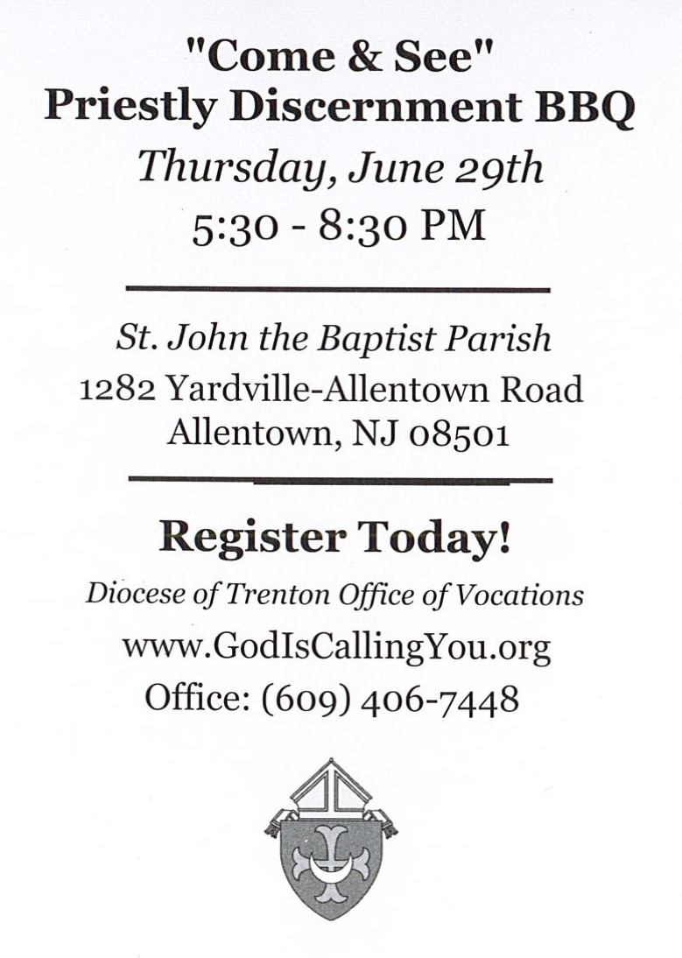

**RETROUVAILLE**

Tens of thousands of couples have healed their marriages through Retrouvaille (pronounced Retro-vy). Couples learn to build communication skills and to increase intimacy. It provides help for marriage problems, difficulties or crises. The Office of Family Life, Diocese of Metuchen, will sponsor a Retrouvaille weekend on August 18-20. For further information, please contact Rich Colasuonno (732-236-0671) or Annette Colasuonno (732-672-0748) or email [3024@helpourmarriage.org](mailto:3024@helpourmarriage.org). The Family Life Center in Malvern, PA will hold Retrouvaille weekends on August 18 - 20 and October 6 – 8. For more information, or to register, visit www.HelpOurMarriage.org or call 215-766-3944 or 800-470-2230. All inquiries are strictly confidential.



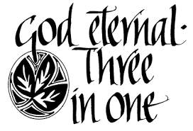

**THE SOLEMNITY OF THE MOST HOLY TRINITY**

Trinity Sunday is the first Sunday after Pentecost in the Western Christian liturgical calendar, however, in Eastern Christianity there is no specific day set aside to celebrate the Christian doctrine of the Trinity. The Eastern Churches point out that they celebrate the Trinity every Sunday. Westerners do as well, we just set aside a special feast day for the purpose. In the West, Trinity Sunday, officially called “The Solemnity of the Most Holy Trinity,” is one of the few celebrations of the Christian Year that commemorates a reality and doctrine rather than an event or person.

Holy Trinity Sunday is celebrated on the first Sunday following Pentecost in most of the liturgical churches in Western Christianity. It is a solemn celebration of the belief in the revelation of one God, yet three divine persons. It was not uniquely celebrated in the early church, but as with many things the advent of new, sometimes heretical, thinking often gives the Church a moment in which to explain and celebrate its own traditions; things it already believes and holds dear. In the early 4th century when the Arian heresy was spreading, the early church, recognizing the inherent Christological and Trinitarian implications, prepared an Office of Prayer with canticles, responses, a preface, and hymns, to be recited on Sundays to proclaim the Holy Trinity. Pope John XXII (14th century) instituted the celebration as a feast for the entire Church; the celebration became a solemnity after the liturgical reforms of Vatican II.

**A PRAYER TO THE BLESSED TRINITY**

Glory be to the Father, Who by His almighty power and love created me, making me in the image and likeness of God. Glory be to the Son, Who by His Precious Blood delivered me from hell, and opened for me the gates of heaven. Glory be to the Holy Spirit, Who has sanctified me in the sacrament of Baptism, and continues to sanctify me by the graces I receive daily from His bounty. Glory be to the Three adorable Persons of the Holy Trinity,  
now and forever.   
Amen.

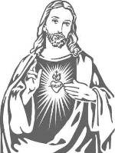

**Solemnity of the Sacred Heart of Jesus**

**Friday, June 16th**

**Please join us in Celebration of our**

**Parish Feast Day**

**at the 12:10 Noon Mass.**

**Pizza will be served following the Mass. In order to be properly prepared, please call the parish office to confirm your attendance by Wednesday, June 14th**



**What is the National Eucharistic Revival?**

**A NATIONAL EUCHARISTIC REVIVAL**

**2022-2025**

We are pleased to announce that our diocese will be participating in a three year-long Eucharistic Revival sponsored by the Bishops of the United States. This initiative seeks to: Provide a more profound encounter with Jesus Christ at Mass and through this powerful encounter, find personal healing and courage to take the Gospel into a world in need of authentic love. To spark personal conversions through a relationship with Christ present in the Eucharist. To elevate the truth and practices of our faith through a rediscovery of the Real Presence of Jesus in the Eucharist. To form, inspire and launch missionary disciples filled with the love of God and neighbor that comes through an encounter with Jesus in the Eucharist. This year we begin phase two: The Year of Parish Revival. More information will follow.

**Sacred Heart Parish Picnic**



At the CYO of Mercer County

453 Yardville-Allentown Road.

Yardville, NJ 08620

July 9, 2023 ~ 1:00-5:00PM

MASS will be Celebrated at 1:15PM

at the Camp Grounds

Our parish will provide

Hot Dogs and Hamburgers, Rolls, Chips, Water and Soft Drinks

Please bring your own side dishes.

This year we ask all who attend to bring a dessert from your country of origin for the sharing table and attach a label to identify your country on the dessert.

All Day Swimming, Games,

Outdoor Recreation, Playground Area

TEAR OFF BOTTOM PORTION AND RETURN

IN THE COLLECTION BASKET OR

SEND TO PARISH OFFICE BEFORE JULY 3rd

~~~~~~~~~~~~~~~~~~~~~~~~~~

Name: __________________________________

__________________________________________

Email address ____________________________

Number attending ___________

